**Weekly Status Report - 2018-MAY-08**

|  |  |
| --- | --- |
| **Project Name** | BiFrost Games |
| **Team Lead** | Devan Weber |

|  |  |  |  |
| --- | --- | --- | --- |
| **Roles** |  |  |  |
| **Week** | **<Pat Horler>** | **<Curtis Naples>** | **<Evan Plant>** |
| 01 | Project Lead, Technical Writer | Technical Writer | Technical Writer |
| 02 | Technical Writer, SQL | HTML, SQL | SQL |
| 03 |  |  |  |
| 04 |  |  |  |
| 05 |  |  |  |
| 06 |  |  |  |
| 07 |  |  |  |
| 08 |  |  |  |

|  |  |  |
| --- | --- | --- |
| **Roles** |  |  |
| **Week** | **<Devan Weber>** | **<Illia Kara>** |
| 01 | Technical Writer | Technical Writer |
| 02 | Project Lead, SQL | SQL |
| 03 |  |  |
| 04 |  |  |
| 05 |  |  |
| 06 |  |  |
| 07 |  |  |
| 08 |  |  |

|  |
| --- |
| **Weekly Project Summary** |
| Database is created, Tables needed are made and have sample data. Data model was finished, UI mockups are also finished, BRD is finished. Gnatt chart has been updated as well. Git is now working and folders and data has been entered |

|  |  |  |  |  |  |
| --- | --- | --- | --- | --- | --- |
| **Key Milestones Status** | | | | | |
| **ID** | **Description** | **Planned Completion** | **Forecasted**  **Completion** | **Actual Completion** | **Status** |
| MS01 | BRD Complete | 2018-MAY-08 | 2018-MAY-08 | 2018-MAY-08 | Closed |
| MS02 | Demo Ready | 2018-MAY-08 | 2018-MAY-08 | 2018-MAY-08 | Closed |
| MS03 | Deliverables Ready | 2018-MAY-08 | 2018-MAY-08 | 2018-MAY-08 | Closed |
| MS04 | DB Complete | 2018-MAY-22 | 2018-MAY-18 | 2018-MAY-17 | Closed |
| MS05 | Demo Ready | 2018-MAY-22 | 2018-MAY-22 | 2018-MAY-17 | Closed |
| MS06 | Deliverables Ready | 2018-MAY-22 | 2018-MAY-22 | 2018-MAY-17 | Closed |
|  |  |  |  |  |  |
|  |  |  |  |  |  |
|  |  |  |  |  |  |
|  |  |  |  |  |  |

|  |
| --- |
| **Key Accomplishments for the Week** |
| * BRD complete * DB complete * UI mockups done * Database model done * Work on HTML started * GitLab is now working |

|  |  |  |  |
| --- | --- | --- | --- |
| **Task Assignments for the Coming Week** | | |  |
| **ID** | **Description** | **Assigned To** | **On Schedule** |
| T09 | Meaningful Data in Database | Evan, Devan | Yes |
| T10 | Client can add products to webpage | Curtis, Pat | Yes |
| T11 | Products can be organized by category | Curtis, Pat | Yes |
| T12 | HTML Product page working | Curtis, Devan, Evan(TL) | Yes |
| T13 | CSS working | Pat | Yes |
| T14 | Continue Gantt Chart | Evan(TL) | Yes |
| T15 | Weekly Task Report | Evan(TL) | Yes |

|  |  |  |
| --- | --- | --- |
| **Task Completed in the Previous Week** | |  |
| **ID** | **Description** | **Assigned To** |
| T02.5 | BRD Section 5 | Curtis, Illia, Evan |
| T02.6 | BRD Section 6 | Curtis |
| T02.7 | BRD put together | Devan |
| T05 | Git Repository Report | Devan |
| T06.1 | Table normalization | Evan, Devan |
| T06.2 | Create Tables | Curtis, Evan |
| T06.3 | Populate tables | Evan |
| T07 | Continue Gnatt Chart | Devan, Pat |
| T08 | Weekly Task Report | Devan |

|  |  |
| --- | --- |
| Issues and Risks |  |
| **Description** | **Impact**  **(L,M,H)** |
| Illia not showing up for group work and classes | M |
|  |  |
|  |  |

|  |
| --- |
| **Gantt Chart** |

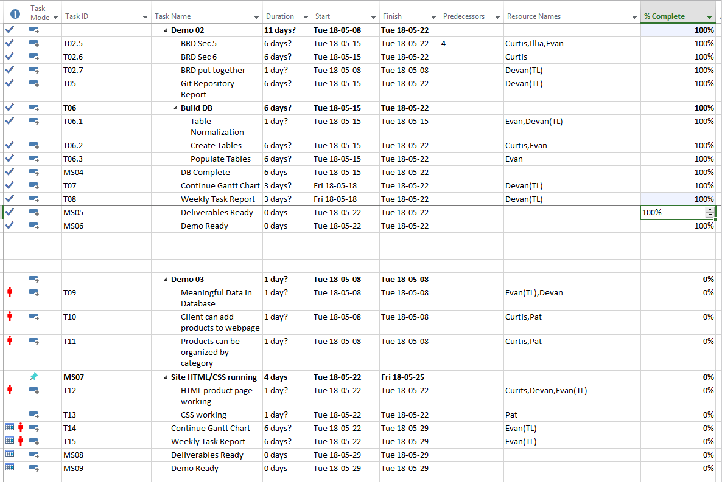

|  |
| --- |
| **Git Log** |

*< Insert Git Log here, use the following command*

*git log --since=1.week --pretty=format:"%an: %s"*

*>*

